CSE520
Samuel Marrujo
Professor Yu
Homework 1

Draw 4 polygons using Eclipse

In this homework, we are to create a cube, tetrahedron, dodecahedron, and icosahedron using Eclipse to create an Android application. I have successfully completed this task, and here is a picture of the following:

Each picture will be on a separate page as shown below.
Cube:

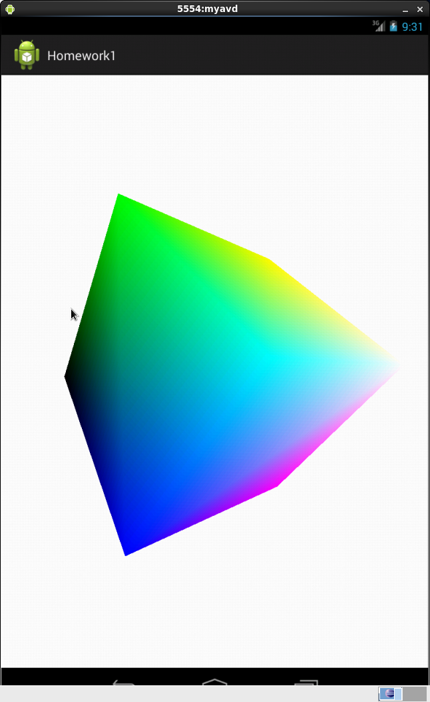
Tetrahedron:
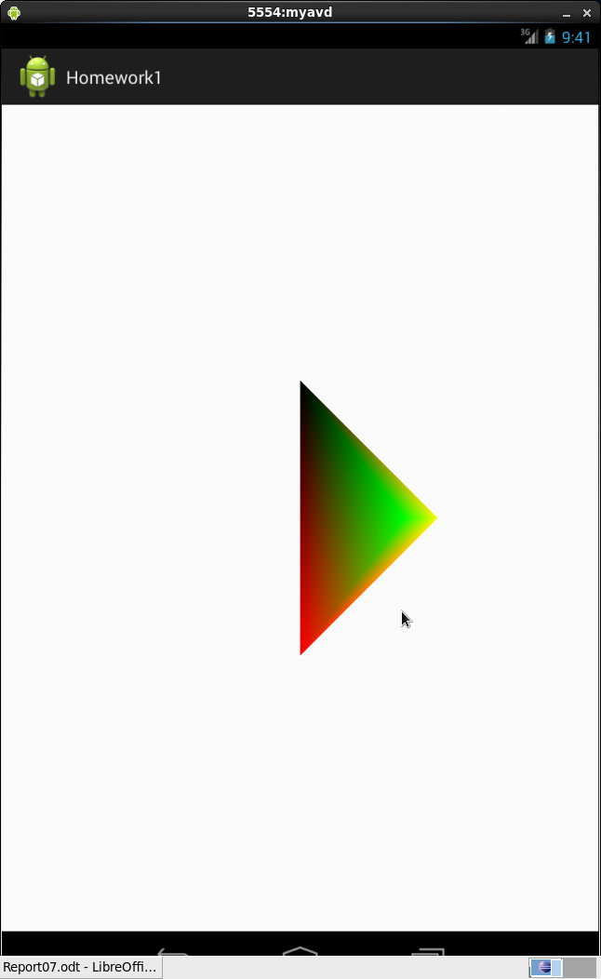
Dodecahedron:
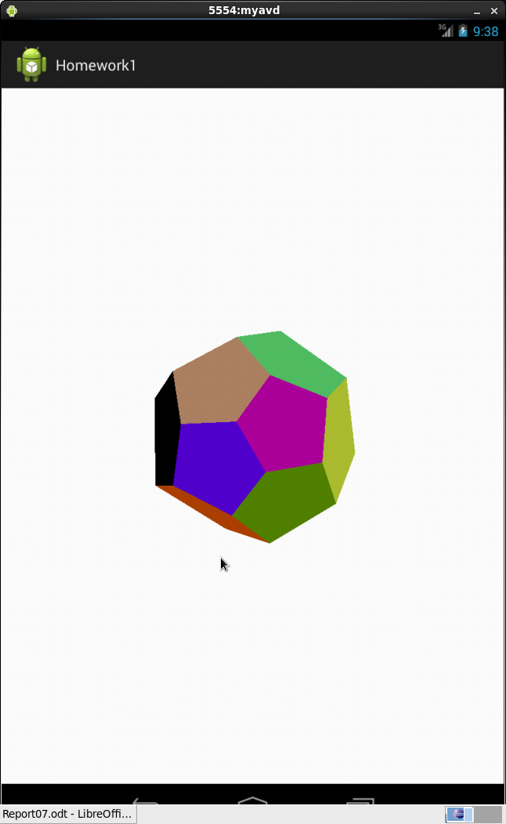
Icosahedron:
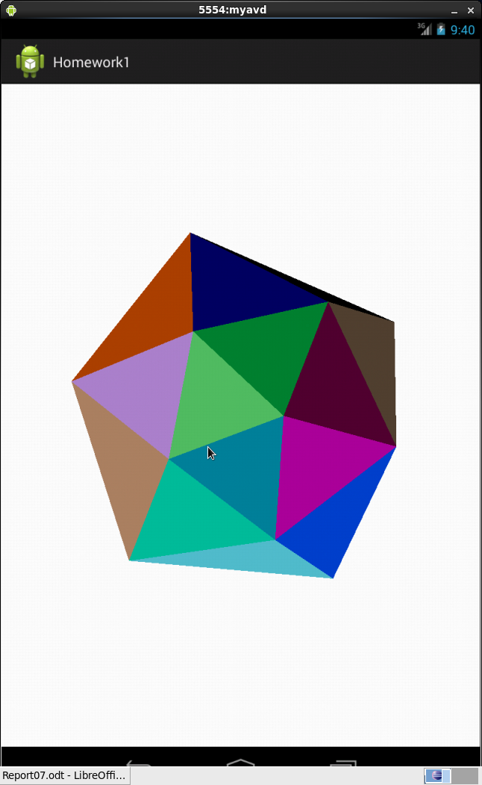
Code:
For each render, I change the “setRenderer(mSOMERenderer);” code to each respective render. This way, it's a simple change into each render I want to show. In the future I want to implement this with a button, but it became incredibly difficult to implement.

package opengl.homework1;
import javax.microedition.khronos.egl.EGLConfig;
import javax.microedition.khronos.opengles.GL10;
import android.view.View.OnClickListener;
import android.widget.ImageView;
import android.widget.TextView;
import android.widget.Button;
import android.graphics.Bitmap;
//import android.graphics.BitmapFactory;
import opengl.homework1.R;
import android.app.Activity;
import android.os.Bundle;
import android.view.View;
import android.opengl.GLSurfaceView;
import android.opengl.GLSurfaceView.Renderer;
import android.view.MotionEvent;
import android.content.Context;

public class MainActivity extends Activity {
Button imageButton;
Button imageButton2;
Button imageButton3;
Button imageButton4;
Bitmap bitmap;
Bitmap bitmap2;
ImageView image;
TextView message;
private GLSurfaceView mGLSurfaceView;

@Override
public void onCreate(Bundle savedInstanceState) {
super.onCreate(savedInstanceState);
mGLSurfaceView = new TouchSurfaceView(this);
setContentView(mGLSurfaceView);
mGLSurfaceView.requestFocus();
mGLSurfaceView.setFocusableInTouchMode(true);

//bitmap = BitmapFactory.decodeResource(this.getResources(), R.drawable.picture);
//bitmap2 = BitmapFactory.decodeResource(this.getResources(), R.drawable.picture2);

//addListenerOnButton();
}

class TouchSurfaceView extends GLSurfaceView {

public TouchSurfaceView(Context context) {
super(context);
mRenderer = new CubeRenderer();
mDodecahedronRenderer = new DodecahedronRenderer();
mTetrahedronRenderer = new TetrahedronRenderer();
mIcosahedronRenderer = new IcosahedronRenderer();

setRenderer(mTetrahedronRenderer);
//RENDERMODE_WHEN_DIRTY means "do not call onDrawFrame() unless
// something explicitly requests rendering with requestRender()
setRenderMode(GLSurfaceView.RENDERMODE_WHEN_DIRTY);
}

@Override public boolean onTrackballEvent(MotionEvent e) {
mRenderer.mAngleX += e.getX() * TRACKBALL_SCALE_FACTOR;
mRenderer.mAngleY += e.getY() * TRACKBALL_SCALE_FACTOR;
/*
mDodecahedronRenderer.anglex += e.getX() * TRACKBALL_SCALE_FACTOR;
mDodecahedronRenderer.anglez += e.getY() * TRACKBALL_SCALE_FACTOR;
mTetrahedronRenderer.mAngleX += e.getX() * TRACKBALL_SCALE_FACTOR;
mTetrahedronRenderer.mAngleY += e.getY() * TRACKBALL_SCALE_FACTOR;
mIcosahedronRenderer.anglex += e.getX() * TRACKBALL_SCALE_FACTOR;
mIcosahedronRenderer.anglez += e.getY() * TRACKBALL_SCALE_FACTOR;
*/
requestRender();
return true;
}

@Override public boolean onTouchEvent(MotionEvent e) {
float x = e.getX();
float y = e.getY();
switch (e.getAction()) {
case MotionEvent.ACTION_MOVE:
float dx = x - mPreviousX;
float dy = y - mPreviousY;
mRenderer.mAngleX += dx * TOUCH_SCALE_FACTOR;
mRenderer.mAngleY += dy * TOUCH_SCALE_FACTOR;
/*
mDodecahedronRenderer.anglex += dx * TOUCH_SCALE_FACTOR;
mDodecahedronRenderer.anglez += dy * TOUCH_SCALE_FACTOR;
mTetrahedronRenderer.mAngleX += dx * TOUCH_SCALE_FACTOR;
mTetrahedronRenderer.mAngleY += dy * TOUCH_SCALE_FACTOR;
mIcosahedronRenderer.anglex += dx * TOUCH_SCALE_FACTOR;
mIcosahedronRenderer.anglez += dy * TOUCH_SCALE_FACTOR;
*/
requestRender();
}
mPreviousX = x;
mPreviousY = y;
return true;
}

private class CubeRenderer implements Renderer {
public CubeRenderer() {
mCube = new Cube();
}

public void onDrawFrame(GL10 gl) {

gl.glClear(GL10.GL_COLOR_BUFFER_BIT | GL10.GL_DEPTH_BUFFER_BIT);

gl.glMatrixMode(GL10.GL_MODELVIEW);
gl.glLoadIdentity();
gl.glTranslatef(0, 0, -3.0f);
gl.glRotatef(mAngleX, 0, 1, 0);
gl.glRotatef(mAngleY, 1, 0, 0);

gl.glEnableClientState(GL10.GL_VERTEX_ARRAY);
gl.glEnableClientState(GL10.GL_COLOR_ARRAY);
mCube.draw(gl);

}

public void onSurfaceChanged(GL10 gl, int width, int height) {
gl.glViewport(0, 0, width, height);

float ratio = (float) width / height;
gl.glMatrixMode(GL10.GL_PROJECTION);
gl.glLoadIdentity();
gl.glFrustumf(-ratio, ratio, -1, 1, 1, 10);
}

public void onSurfaceCreated(GL10 gl, EGLConfig config) {

gl.glDisable(GL10.GL_DITHER);

gl.glHint(GL10.GL_PERSPECTIVE_CORRECTION_HINT,
GL10.GL_FASTEST);

gl.glClearColor(1,1,1,1);
gl.glEnable(GL10.GL_CULL_FACE);
gl.glShadeModel(GL10.GL_SMOOTH);
gl.glEnable(GL10.GL_DEPTH_TEST);
}
private Cube mCube;
public float mAngleX;
public float mAngleY;
}

private class TetrahedronRenderer implements Renderer {
public TetrahedronRenderer() {
mTetrahedron = new Tetrahedron();
}

public void onDrawFrame(GL10 gl) {

gl.glClear(GL10.GL_COLOR_BUFFER_BIT | GL10.GL_DEPTH_BUFFER_BIT);

gl.glMatrixMode(GL10.GL_MODELVIEW);
gl.glLoadIdentity();
gl.glTranslatef(0, 0, -3.0f);
gl.glRotatef(mAngleX, 0, 1, 0);
gl.glRotatef(mAngleY, 1, 0, 0);

gl.glEnableClientState(GL10.GL_VERTEX_ARRAY);
gl.glEnableClientState(GL10.GL_COLOR_ARRAY);
mTetrahedron.draw(gl);

}

public void onSurfaceChanged(GL10 gl, int width, int height) {
gl.glViewport(0, 0, width, height);

float ratio = (float) width / height;
gl.glMatrixMode(GL10.GL_PROJECTION);
gl.glLoadIdentity();
gl.glFrustumf(-ratio, ratio, -1, 1, 1, 10);
}

public void onSurfaceCreated(GL10 gl, EGLConfig config) {

gl.glDisable(GL10.GL_DITHER);

gl.glHint(GL10.GL_PERSPECTIVE_CORRECTION_HINT,
GL10.GL_FASTEST);

gl.glClearColor(1,1,1,1);
gl.glEnable(GL10.GL_CULL_FACE);
gl.glShadeModel(GL10.GL_SMOOTH);
gl.glEnable(GL10.GL_DEPTH_TEST);
}
private Tetrahedron mTetrahedron;
public float mAngleX;
public float mAngleY;
}
public class DodecahedronRenderer implements Renderer
{
GL10 gl;
Dodecahedron dodecahedron = new Dodecahedron();
private float anglex;
private float anglez;
private final int nfaces = 12;
//@Override
//Refresh automatically
public void onDrawFrame(GL10 gl)
{
gl.glClear(GL10.GL_COLOR_BUFFER_BIT | GL10.GL_DEPTH_BUFFER_BIT);
gl.glEnableClientState(GL10.GL_VERTEX_ARRAY);
gl.glEnableClientState(GL10.GL_COLOR_ARRAY);
gl.glMatrixMode(GL10.GL_MODELVIEW);
gl.glLoadIdentity();
gl.glTranslatef(0.0f, 0.0f, -3.0f);
gl.glRotatef( anglex, 1.0f, 0.0f, 0.0f ); // Rotate about x-axis
gl.glRotatef( anglez, 0.0f, 0.0f, 1.0f); // Rotate about z-axis
dodecahedron.draw(gl);
anglex += 1.0f;
anglez += 2.0f;
gl.glDisableClientState(GL10.GL_VERTEX_ARRAY);
gl.glDisableClientState(GL10.GL_COLOR_ARRAY);
}

public void onSurfaceChanged(GL10 gl, int width, int height)
{
gl.glViewport(0, 0, width, height);
float ratio = (float) width / height;
gl.glMatrixMode(GL10.GL_PROJECTION);
gl.glLoadIdentity();
gl.glFrustumf(-ratio, ratio, -1, 1, 1, 10);
}

public void onSurfaceCreated(GL10 gl, EGLConfig config)
{
gl.glDisable(GL10.GL_DITHER);
gl.glHint(GL10.GL_PERSPECTIVE_CORRECTION_HINT, GL10.GL_FASTEST);
gl.glClearColor(1, 1, 1, 0);
gl.glEnable(GL10.GL_CULL_FACE);
gl.glShadeModel(GL10.GL_SMOOTH);
gl.glEnable(GL10.GL_DEPTH_TEST);
}
}
public class IcosahedronRenderer implements Renderer
{
GL10 gl;
Icosahedron icosahedron = new Icosahedron();
private float anglex;
private float anglez;
private final int nfaces = 20;
//@Override
//Refresh automatically
public void onDrawFrame(GL10 gl)
{
gl.glClear(GL10.GL_COLOR_BUFFER_BIT | GL10.GL_DEPTH_BUFFER_BIT);
gl.glEnableClientState(GL10.GL_VERTEX_ARRAY);
gl.glEnableClientState(GL10.GL_COLOR_ARRAY);
gl.glMatrixMode(GL10.GL_MODELVIEW);
gl.glLoadIdentity();
gl.glTranslatef(0.0f, 0.0f, -2.0f);
gl.glRotatef( anglex, 1.0f, 0.0f, 0.0f ); // Rotate about x-axis
gl.glRotatef( anglez, 0.0f, 0.0f, 1.0f); // Rotate about z-axis
icosahedron.draw(gl);
anglex += 1.0f;
anglez += 2.0f;
gl.glDisableClientState(GL10.GL_VERTEX_ARRAY);
gl.glDisableClientState(GL10.GL_COLOR_ARRAY);
}

public void onSurfaceChanged(GL10 gl, int width, int height)
{
gl.glViewport(0, 0, width, height);
float ratio = (float) width / height;
gl.glMatrixMode(GL10.GL_PROJECTION);
gl.glLoadIdentity();
gl.glFrustumf(-ratio, ratio, -1, 1, 1, 10);
}

public void onSurfaceCreated(GL10 gl, EGLConfig config)
{
gl.glDisable(GL10.GL_DITHER);
gl.glHint(GL10.GL_PERSPECTIVE_CORRECTION_HINT, GL10.GL_FASTEST);
gl.glClearColor(1, 1, 1, 0);
gl.glEnable(GL10.GL_CULL_FACE);
gl.glShadeModel(GL10.GL_SMOOTH);
gl.glEnable(GL10.GL_DEPTH_TEST);
}
}

private final float TOUCH_SCALE_FACTOR = 180.0f / 320;
private final float TRACKBALL_SCALE_FACTOR = 36.0f;
private CubeRenderer mRenderer;

private DodecahedronRenderer mDodecahedronRenderer;
private TetrahedronRenderer mTetrahedronRenderer;
private IcosahedronRenderer mIcosahedronRenderer;

private float mPreviousX;
private float mPreviousY;

}

//define Listeners
public void addListenerOnButton() {
imageButton = (Button) findViewById(R.id.imageButton1);
imageButton2 = (Button) findViewById(R.id.imageButton2);
imageButton3 = (Button) findViewById(R.id.imageButton3);
imageButton4 = (Button) findViewById(R.id.imageButton4);

imageButton.setOnClickListener(new OnClickListener() {
@Override
public void onClick(View view) {
message = (TextView) findViewById(R.id.message);
image = (ImageView) findViewById(R.id.carimage);
message.setText("Cube");
//image.setImageBitmap(bitmap);
}
});

imageButton2.setOnClickListener(new OnClickListener() {
@Override
public void onClick(View view) {
message = (TextView) findViewById(R.id.message);
image = (ImageView) findViewById(R.id.carimage);
message.setText("Tetrahedron");
//image.setImageBitmap(bitmap2);
}
});
imageButton3.setOnClickListener(new OnClickListener() {
@Override
public void onClick(View view) {
message = (TextView) findViewById(R.id.message);
image = (ImageView) findViewById(R.id.carimage);
message.setText("Dodecahedron");
//image.setImageBitmap(bitmap);
}
});
imageButton4.setOnClickListener(new OnClickListener() {
@Override
public void onClick(View view) {
message = (TextView) findViewById(R.id.message);
image = (ImageView) findViewById(R.id.carimage);
message.setText("Icosahedron");
//image.setImageBitmap(bitmap);
}
});
}
@Override
protected void onPause() {
super.onPause();
// The following call pauses the rendering thread.
mGLSurfaceView.onPause();
}

@Override
protected void onResume() {
super.onResume();
// The following call resumes a paused rendering thread.
mGLSurfaceView.onResume();
}
}

